**Q1**

Code: 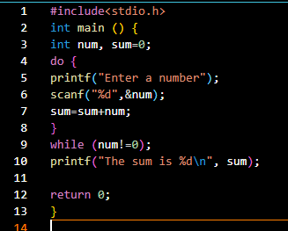

Output: 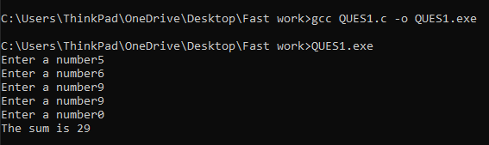

**Q2**

Code: 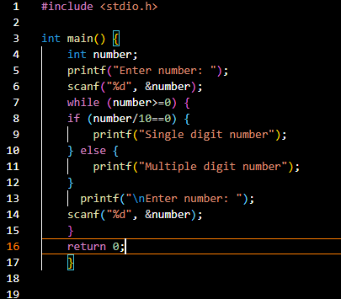

Output: 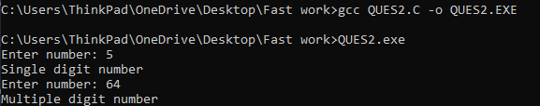

**Q3**

Code: 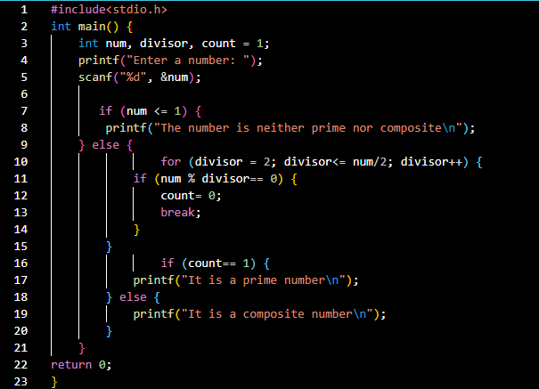

Output: 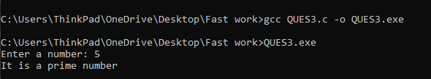

**Q4:**

Code: 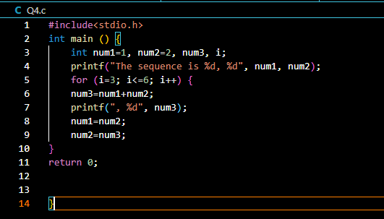

Output: 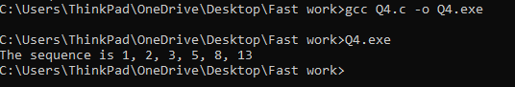

**Q5**

Code: 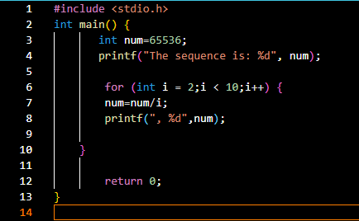

Output: 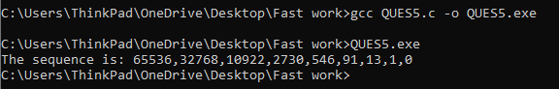

**Q6**

Code: 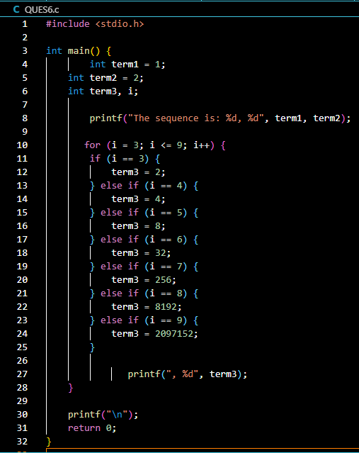

Output: 